BACHELOR OF BUSINESS ADMINISTRATION

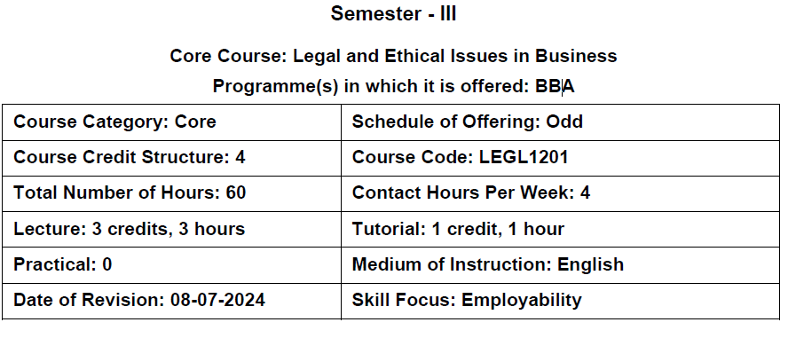
Course Content:

Unit 1: Introduction to Business Law
Business law – definition, scope, importance of understanding the role of law in business; Elements of a contract – offer and acceptance, consideration, contractual capacity; Essentials of a valid contract; Types of contracts.

Unit 2: Sale of Goods Act, 1930

Essential conditions of a contract of Contract Sales, Transfer of ownership, Conditions and Warranties, Performance of the contract of Sale, Rights of Unpaid Seller, Auction Sales.

Unit 3: Introduction to Business Ethics

Ethics- Meaning, Importance and Nature, The “Seven Principles of Public Life” – Selflessness, Integrity, Objectivity, Accountability, Openness, Honesty and Leadership, The Relationship between Ethics and Law, benefits of Ethical Conduct in Business, Ethical Issues and Stakeholder Concerns, Issues related to Business Ethics in marketing, finance & human resource functions, Ethical responsibilities of multinational corporations related to discrimination, human rights, environmental impact, and intellectual property.

Unit 4: The Ethical Decision-making process

Philosophical, moral, legal, and religious approaches: (Ethics in the Bhagavad Gita, Kautilya’s Arthashastra, Swami Vivekananda’s views on ethics and youth empowerment.)

Indian Philosophy and Work Ethics: (Karmayoga, integral humanism, and Indian perspectives on work ethics.)

Ethics in Organizations: (Individual and organizational factors influencing ethical decisions; frameworks for ethical decision-making; corporate governance and whistleblowing, Conflict Resolution

Readings:
Text Books (Latest Edition):

1. Tulsian, P. C. Business and Corporate Laws. S. Chand Publishing.
2. Fernando, A.C. Business Ethics and Corporate Governance. Pearson
3. Bayern, S. Business Law Beyond Business. J. Corp. L., 46, 521.
4. Vivekanand, S. To the Youth of India. Advaita Ashrama.

References:

- Ratan Tata: Ethical Leadership| By: Ashok K. Dua, Sumita Rai| Ivey Publishing
- https://hbsp.harvard.edu/product/W17258-PDF-ENG
- www.https://scroll.in/tag/competition-commission-of-India
- Mascarenhas, A. J. O. et al. (2019). J.R.D. Tata: Orations on Business Ethics. Rupa Publications India
- Holloway, J. E. (2023). The Foundation of the Theory of Law and Business. Am. U. Bus. L. Rev., 12, 51.
- Vivekanand, S. (2022) Karam Yoga: The Yoga of action. Sanage Publishing House LLP
- Vivekanand, S. (2015): Lectures on Bhagavad Gita. CreateSpace Independent Publishing Platform
- Laasch, O. (2022). Principles of Management. Sage Textbook

Evaluation Pattern
Evaluation Matrix Continuous Internal  Assessment (CIA) Components* | Component Type |  |  | Weightage Percentage |  | Total  Marks |  | Tentative Dates |  |  | Course Outcome Mapping
Internal Exam 1  Internal Exam 2  Internal Exam 2 |  | 33.33% |  |  | 10 |  | Week 4  Week 8  Week 13 |  |  | 1 & 2
Assignment |  | 33.33% |  |  | 10 |  | Week 3 & 10 |  |  | 1 & 3
Presentations/ Quizzes |  | 33.33% |  |  | 10 |  | Week 8 & 9 |  |  | 1,2,3, 4
CIA Marks |  |  |  | 100% |  |  |  | 30
ESE |  |  | 70% |  |  | 70 |  |  | 1,2,3,4

